ShopNest Store Business Analytics Dashboard Report

Dashboard Overview
The ShopNest Store dashboard was created in Power BI using 9 connected e-commerce datasets. The dashboard analyses key business areas such as sales performance, delayed deliveries, payment methods, customer ratings, regional sales, seasonal trends, and yearly revenue. KPI cards and slicers were added to make the dashboard interactive and easy to understand.

Question 1: Top Categories by Total Price
Question Statement
Identify and visually represent the top 10 product categories by total sales.
Visualization Used
Clustered bar chart.
Explanation
This chart shows the top 10 product categories based on total sales value. The product category is displayed on the Y-axis, while total sales are shown on the X-axis. From the visualization, health_beauty has the highest sales, followed by watches_gifts and bed_bath_table. This shows that these categories are the strongest revenue contributors for ShopNest. The chart helps the business identify which product categories should be prioritized for stock planning, marketing campaigns, and sales strategy.
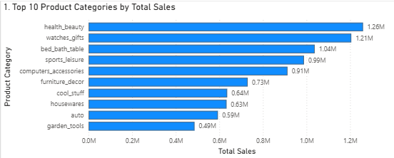

Question 2: Delayed Orders Analysis
Question Statement
Determine the number of delayed orders in each category. An order is considered delayed if the actual delivery date is later than the estimated delivery date.
Visualization Used:
Clustered bar chart.
Explanation
This chart shows the product categories with the highest number of delayed orders. A delayed order was calculated by comparing the actual delivery date with the estimated delivery date. If the actual delivery date was later than the estimated delivery date, the order was counted as delayed. The chart shows that categories such as bed_bath_table, health_beauty, and sports_leisure have a higher number of delayed orders. This helps the business identify categories where delivery performance may need improvement.
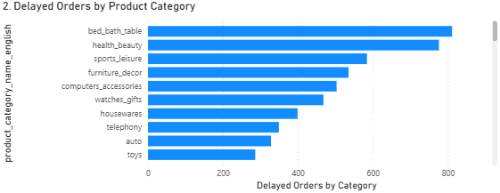

Question 3: Monthly Comparison of Delayed and On-Time Orders
Question Statement
Create a dynamic visual that compares the number of delayed orders to the number of orders received earlier for each month. Utilize the drillthrough cross-report feature to provide detailed analysis of late and on-time deliveries.
Visualization Used
Clustered column chart.
Explanation
This chart compares delayed orders and on-time orders for each month. The X-axis shows the month and year, while the Y-axis shows the number of orders. Two bars are shown for each month: one for delayed orders and one for on-time orders. This visual helps identify months where delivery performance was strong or weak. From the dashboard, on-time orders are generally higher than delayed orders, but some months show noticeable delivery delays. This helps ShopNest track delivery performance over time and understand whether delays are increasing or decreasing.
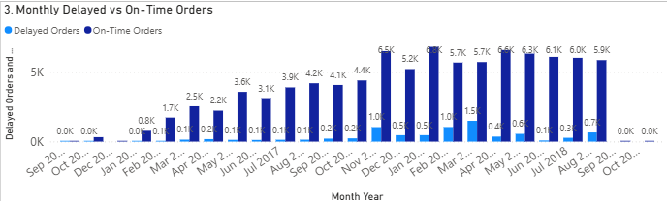

Question 4: Payment Method Analysis
Question Statement
Analyze the most frequently used payment methods by customers using a visually appealing representation, such as a pie chart or other suitable visuals.
Visualization Used
Donut chart.
Explanation
This donut chart shows the payment methods used by customers. The chart displays payment types such as credit_card, boleto, voucher, debit_card, and not_defined. From the visualization, credit card is the most frequently used payment method, with the highest number of transactions. Boleto is the second most used payment method. This insight helps ShopNest understand customer payment preferences and can support payment experience improvements.
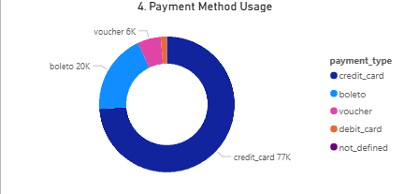

Question 5: Product Rating Analysis
Question Statement
Determine the top 10 highest-rated products and the bottom 10 lowest-rated products using a bar or column chart.
Visualization Used
Two clustered bar charts.
Explanation
Two bar charts were created for product rating analysis. The first chart shows the top 10 highest-rated products, while the second chart shows the bottom 10 lowest-rated products. Product ratings were calculated using customer review scores. The highest-rated products have ratings close to 5.00, while the lowest-rated products have ratings around 1.00. This comparison helps ShopNest identify products that customers are highly satisfied with and products that may require quality checks, seller review, or customer service attention.
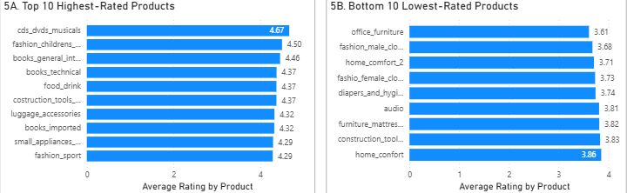
Question 6: State-wise Sales Analysis
Question Statement
Identify and visually represent states with high and low sales, providing a clear understanding of regional sales performance.
Visualization Used
Clustered bar chart.
Explanation
This chart shows total sales by customer state. The state is displayed on the Y-axis, while total sales are shown on the X-axis. The visualization shows that SP has the highest sales by a large margin, followed by states such as RJ and MG. This means ShopNest has stronger sales performance in certain regions. The chart helps the business understand where customer demand is highest and where there may be opportunities to improve sales through targeted marketing or regional expansion.
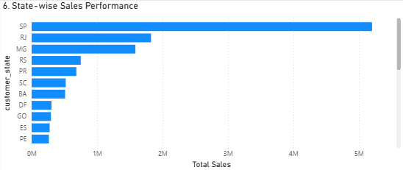

Question 7: Seasonal Sales Patterns
Question Statement
Investigate and visualize any seasonal patterns or quarterly trends in sales data over the course of the year.
Visualization Used
Line chart.
Explanation
This line chart shows sales trends by quarter. The X-axis shows year and quarter, while the Y-axis shows total sales. The chart helps identify whether sales increase or decrease during specific quarters. From the visualization, sales were stronger during later periods and lower in earlier quarters. This helps ShopNest understand seasonal sales behavior and plan promotions, inventory, and business activities according to demand patterns.
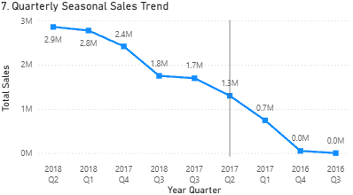

Question 8: Revenue Analysis
Question Statement
Determine the total revenue generated by ShopNest Store and analyze how it changes over time yearly. Represent this information through suitable visuals to highlight trends and patterns.
Visualization Used
KPI card and clustered column chart.
Explanation
The total revenue KPI card shows the overall revenue generated by ShopNest, which is approximately 13.59M. The yearly revenue chart shows how revenue changed across different years. From the visualization, revenue increased significantly from 2016 to 2017 and further increased in 2018. This indicates strong business growth over time. The revenue analysis helps ShopNest understand yearly performance and evaluate overall business progress.
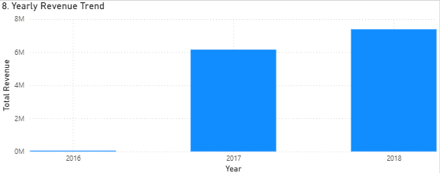

Dashboard Conclusion
The Power BI dashboard provides a complete business overview of ShopNest Store. It highlights the best-performing product categories, delayed delivery patterns, customer payment behavior, product ratings, state-wise sales, seasonal sales trends, and yearly revenue growth. These insights can help ShopNest improve logistics, focus on high-performing categories, monitor low-rated products, and make better business decisions.

Full Chart:
